**KHYBER PAKHTUNKHWA HUMAN CAPITAL INVESTMENT PROJECT (kphcip)**

**Monitoring Report of ALP Centers**

**District Peshawar**

**Visit Date:** 14 June 2023

**District:** Peshawar

**Visiting Team:**  Maria Rehman (M&E Officer) and Asia Jaan (Education Officer)

**Visit Objective:** Monitoring Visit of Accelerated Learning Program (ALP) Centers

**Report Prepared By:** Maria Rehman (M&E Officer)

The Project Implementation Unit (PIU), Accelerated Learning Program (ALP) is tasked to establish 327 ALP centers in the four selected project districts under KP-HCIP education. These centers aim to provide quality accelerated education to out-of-school children through a purposefully designed curriculum to enable children to catch up on lost time. The ALP centers under the project were established in April 2023 at Peshawar (107), Nowshera (114), Haripur (34), and Swabi (72), with a focus on Afghan refugees’ children and the hosting communities. The centers operate in morning and evening shifts to facilitate the children.

**Objectives of the visit were:**

1. to assess the operational status of the ALP centers,
2. to verify the supplies provided under the project,
3. to take feedback from students, teachers, and the community in general about the ALP centers.

**On 14 Jun 2023, nine ALP centers in District Peshawar were visited following;**

|  |  |  |  |  |  |
| --- | --- | --- | --- | --- | --- |
| Sr# | Center Name | Gender | Total Learners Enrolled | Local Learners | Afghan Refugees |
| 1 | Landi Arbab Manak Raw | Female | 35 | 31 | 04 |
| 2 | Rehan Abad Landi Arbab | Female | 35 | 27 | 08 |
| 3 | Ameen Colony Landi Arbab | Female | 32 | 28 | 04 |
| 4 | Mohalla Gulab Khan Landi Arbab | Female | 35 | 28 | 07 |
| 5 | Gari Loharan/Charkha Khel Sherali Malat | Female | 35 | 31 | 04 |
| 6 | GGPS Charkha Khel | Female | 35 | 20 | 15 |
| 7 | GGPS Charkha Khel | Female | 35 | 30 | 05 |
| 8 | GGPS Charkha Khel | Female | 33 | 30 | 03 |
| 9 | Swati Phatak Umeed Abad No.02 | Female | 30 | 22 | 08 |
| Total | | | **305** | **247** | **58** |

**Center-wise details are as follows;**

1. **ALP Center Landi Arbab Manak Raw (Female)**

|  |  |  |  |  |  |
| --- | --- | --- | --- | --- | --- |
| Total Learners Registered | Local Learners | Afghan Refugees | Withdrawal | Present at the time of visit | No. Of Facilitators |
| 35 | 31 | 04 | 02 | 29 | 02 |

**Key Findings:**

* The center is located in the facilitator’s house and has been operational since April 2023.
* The center is functioning during the morning shift from 08:00 am to 01:00 pm.
* The ALP-PIU supplied various items to this center, including a signboard, whiteboard, school bags, notebooks, package-D, dictionaries, water cooler, two steel tumblers (glasses), and charts. However, facilitator and learner chairs were not supplied till the visit date.
* A group of people sitting on the floor reading books

  Description automatically generated with low confidenceThe center was small and overcrowded, barely enough to accommodate the 29 learners present on the day of the visit. Seating all the 35 enrolled students seemed to be a difficult challenge.

Figure : View of ALP center and notebooks provided by PIU

* Drinking water and washroom facilities were available to learners.
* The age range of the learners in the center was between 12 and 18 years.
* Both facilitators (Ms. Suman Dilraz Khan and Ms. Dilawez) were residents of the area and were also present at the center.
* 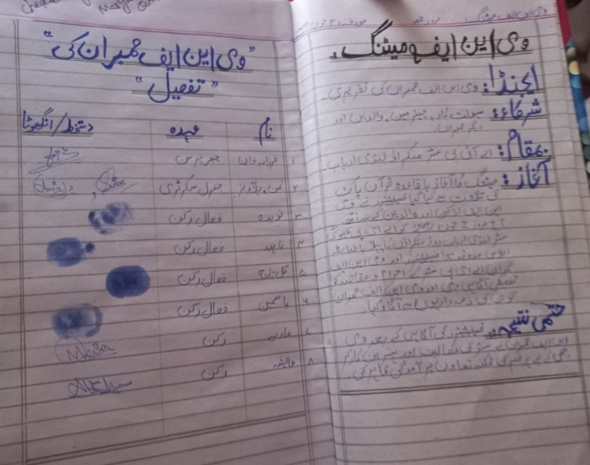Facilitators received contracts for a period of nine months, from April to December 2023 and they also received a stipend of Rs 50,000 each for the first two months (April-May 2023).

Figure : Record of Agenda, Meeting minutes and members detail in VNF register

* All registers, including Learners’ Attendance, Staff Attendance, VNF, Stock, Learners’ Admission and Withdrawals, and Visitors Register were properly maintained and updated.
* A Volunteer Network Forum (VNF) consisting of 08 female members was established, and the minutes of the VNF meeting were recorded and updated in the VNF register, along with the members details.

1. **ALP Center Rehan Abad Landi Arbab (Female)**

|  |  |  |  |  |  |
| --- | --- | --- | --- | --- | --- |
| Total Learners Registered | Local Learners | Afghan Refugees | Withdrawal | Present at the time of visit | No. Of Facilitators |
| 35 | 27 | 08 | 02 | 23 | 02 |

**Key Findings:**

Figure : Inside view of ALP center

* The center is in the facilitator’s house and has been operational since 1st April 2023.
* The center is functioning during the morning shift from 07:30 am to 12:30 pm.
* Various items including a signboard, whiteboard, school bags, notebooks, Package-D, dictionaries, water cooler, and Charts were delivered to this center by the ALP-PIU. However, facilitator and learner chairs were not supplied till visit day.
* During the visit, it was noted that 12 learners were absent. When asked about the reason for their absence, the facilitators explained that a significant number of students did not attend the center due to the hot weather conditions.
* The Learners were housed in a single room with enough lighting.
* A picture containing abandoned, building, ground, wall

  Description automatically generatedThe center did not have a washroom facility available for the learners due to ongoing construction in the building. It is recommended to prioritize the provision of a washroom for the learners.

Figure : Ongoing construction of washroom

* The learners in this center were primarily between the ages of 12 and 18 years.
* According to the facilitators, PIU will pay them an amount of 1500 for the electricity bill.
* Both facilitators (Ms. Ayesha Bibi and Ms. Syeda Afshin) were residents of the area and they were present at the center.
* Facilitators received a contractual agreement for a period of nine months, from April to December 2023 and they also received a stipend of Rs 50,000 each for the first two months (April-May 2023).
* All the registers, including Learners’ Attendance, Staff Attendance, VNF, Stock, Learners’ Admission and Withdrawal, and Visitors Register were properly maintained and updated.
* A Volunteer Network Forum (VNF) consisting of 08 members was established including 06 female and 02 male members, and the minutes of the VNF meeting were recorded and updated in the VNF register, along with the members’ details.
* 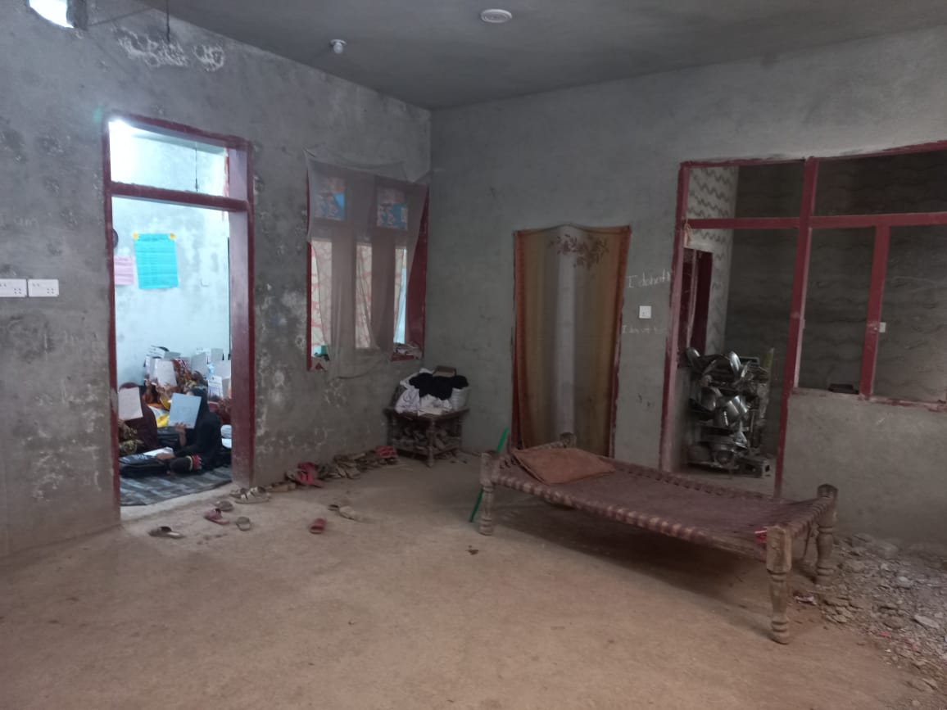Upon feedback from the learners, it was revealed that there were no primary or middle schools available in Rehan Abad area. The establishment of this ALP center has providedthe community with a unique opportunity. The learners expressed their satisfaction and gratitude for having the ALP center.

Figure : Under construction building structure

1. **ALP Center Ameen Colony Landi Arbab (Female)**

|  |  |  |  |  |  |
| --- | --- | --- | --- | --- | --- |
| Total Learners Registered | Local Learners | Afghan Refugees | Withdrawal | Present at the time of visit | No. Of Facilitators |
| 32 | 28 | 04 | 02 | 25 | 02 |

**Key Findings:**

* A group of people sitting on the floor

  Description automatically generatedThe ALP center has been operating since 1st April 2023, and it is situated in a rented room.
* The center is functioning during the morning shift with timings from 08:00 am to 01:00 pm.
* Supplies including a signboard, school bags, notebooks, a whiteboard, Package-D, dictionaries, a water cooler, two steel tumblers (glasses), and charts were provided to the center by the ALP-PIU. However, facilitator and learner chairs were not supplied till the visit day.

Figure : Inside view of ALP center

* The facilitator informed that PIU will pay Rs 1500 per month for the electricity bill.
* 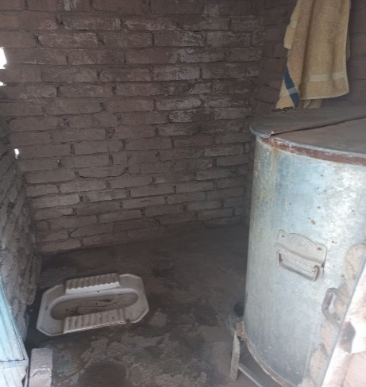The learners were properly accommodated in a single room that had enough space and lighting to meet the learner’s needs.
* A washroom was available, however, it needed improvement.
* Drinking water was available in this center.
* The age range of the learners in this center was between 12 and 18 years.
* Both facilitators (Ms. Najma Arshad and Ms. Sadia) were locals of the area and were present during the visit to the center.

Figure : Available washroom facility in ALP center

* Facilitators received a contractual agreement for a period of nine months, from April to December 2023 and they also received a stipend for the first two months (April-May 2023).
* In this center, a Volunteer Network Forum (VNF) was formed, comprising of 08 members, including 07 females and 01 male chairperson. A meeting of the VNF was held on May 25, 2023. Although the roles and responsibilities of the VNF were not displayed, they were documented and updated in the VNF registers along with the names of the members.

1. **ALP Center Mohalla Gulab Khan Landi Arbab (Female)**

|  |  |  |  |  |  |
| --- | --- | --- | --- | --- | --- |
| Total Learners Registered | Local Learners | Afghan Refugees | Withdrawal | Present at the time of visit | No. Of Facilitators |
| 35 | 28 | 07 | 01 | 25 | 02 |

**Key Findings:**

* During the visit to this center, it was revealed that the ALP center has been shifted from GGHSS school to the facilitator's house because the principal of GGHSS school did not permit the establishment of the ALP center within the school premises. Additionally, signboard was not installed because the signboard displayed the address of GGHSS school instead of the new location.

Figure : View of uninstalled signboard

* The center is functioning during the evening shift with the timings from 01:30 pm to 06:30 pm.
* Various items including a signboard, whiteboard, school bags, notebooks, Package-D, dictionaries, water cooler, Two steel glasses, and charts were supplied by the ALP-PIU. However, facilitator and learner chairs were not supplied till visit day.
* The Learners were accommodated into a single room with sufficient lighting.
* The center also had a washroom facility available to the learners.
* The learners in this center were primarily between the ages of 12 and 18 years.
* Ms. Maryam Shah, a local resident, and Ms. Umme Habiba, who travels daily from Bazid Khel, were both present at the center.
* Both facilitators received contract agreements for a period of nine months, from April to December 2023 and they also received a stipend of Rs 50,000 each for the first two months (April-May 2023).
* All the registers, including Learners’ Attendance, Staff Attendance, VNF, Stock, Learners Admission and Withdrawal and Visitors Register were properly maintained and updated.
* A Volunteer Network Forum (VNF) consisting of 08 members was established including 07 female and 01 male member, and the minutes of the VNF meeting were recorded in the VNF register, along with the member’s details.

1. **ALP Center Gari Loharan/Charkha Khel Sherali Malat (Female)**

|  |  |  |  |  |  |
| --- | --- | --- | --- | --- | --- |
| Total Learners Registered | Local Learners | Afghan Refugees | Withdrawal | Present at the time of visit | No. Of Facilitators |
| 35 | 31 | 04 | 00 | 16 | 02 |

**Key Findings:**

Figure : View of uninstalled Signboard

* During the visit to this center, it was found that the center had been relocated from a private school to the facilitator's house. This decision was made due to the refusal of the school's principal to allow the establishment of the ALP center on the school premises. Moreover, it was noted that the signboard was not installed, and the displayed address on the signboard was different from the actual location. It is recommended to ensure the installation of clear and visible signboards at the ALP center, prominently displaying the name and location of the center.
* The center is functioning during the evening shift from 01:30 pm to 06:30 pm.
* Various items including Sign Board, whiteboard, School Bags, Notebooks, Package-D, Dictionaries, Water Cooler, Two Steel Glasses, and Charts were supplied by the ALP-PIU. However, facilitator and learner chairs were not supplied till visit day.
* A group of people sitting on the floor with books covering their faces

  Description automatically generated with medium confidenceIt was observed that the room was small and overcrowded, making it difficult to accommodate even the 16 learners present on the day. Furthermore, there was no additional room available to accommodate all learners adequately. It is suggested to provide more suitable premises for learners, ensuring sufficient space for movement, seating, and learning activities.

Figure : Inside view of ALP center

* The center has a washroom facility available for the learners.
* In this center, all learners were within the age range of 12 to 18 years.
* Both facilitators, Ms. Noreen, a local resident, and Ms. Neelum (non-local) were present at the center.
* Facilitators received contract agreements for a period of nine months, from April to December 2023 and they also received a stipend of Rs 50,000 each for the first two months (April-May 2023).
* All the registers, including Learners’ Attendance, Staff Attendance, VNF, Stock, Learners Admission and Withdrawal, and Visitors Register were found properly maintained.
* A Volunteer Network Forum (VNF) consisting of 08 members was established including 07 female and 01 male. Minutes of the VNF meeting were recorded and updated in the VNF register, along with the members’ details.

1. **ALP Center GGPS Charkha Khel (Female)**

|  |  |  |  |  |  |
| --- | --- | --- | --- | --- | --- |
| Total Learners Registered | Local Learners | Afghan Refugees | Withdrawal | Present at the time of visit | No. Of Facilitators |
| 35 | 20 | 15 | 02 | 22 | 02 |

**Key Findings:**

* The center is located in Government Girls Primary School Charkha Khel and has been operational since April 1st, 2023.
* The center is functioning during the evening shift from 01:30 pm to 06:30 pm.
* Various items including a signboard, a white board, school bags, notebooks, Package-D, dictionaries, water cooler, two steel tumblers, and charts were delivered to this center by the ALP-PIU. However, facilitator and learner chairs were not supplied till visit day. The A group of people sitting on the floor in a classroom holding papers

  Description automatically generated with medium confidencesignboard was not installed as the head teacher did not permit them to install the signboard. Additionally, the facilitators mentioned that the principal didn’t take furniture, stating that the school already had sufficient furniture for both students and teachers.

Figure : Inside view of ALP center

* The Learners were accommodated into a single room with good lighting.
* The center has a proper washroom facility available, and drinking water is also available.
* The majority of learners in this center were between the ages of 12 and 18 years. However, it was observed that a few learners were outside this age range, specifically 20 years old.
* Both facilitators (Ms. Mehreen Bibi and Ms. Saba Gul) were residents of the area and they were present at the center.
* Facilitators received contract agreements for a period of nine months, from April to December 2023 and they also received a stipend of Rs 50,000 each for the first two months (April-May 2023).
* All the registers, including Learners’ Attendance, Staff Attendance, VNF, Stock, Learners' Admission and Withdrawal and Visitors Register were found properly maintained and updated.
* A Volunteer Network Forum (VNF) consisting of 08 members was established including 07 female and 01 male, and the minutes of the VNF meeting were recorded and updated in the VNF register, along with the members details.

1. **ALP Center GGPS Charkha Khel (Female)**

|  |  |  |  |  |  |
| --- | --- | --- | --- | --- | --- |
| Total Learners Registered | Local Learners | Afghan Refugees | Withdrawal | Present at the time of visit | No. Of Facilitators |
| 35 | 30 | 05 | 08 | 24 | 02 |

**Key Findings:**

* The center is located in Government Girls Primary School Charkha Khel and has been operational since April 1st, 2023.
* A group of people sitting in a classroom holding up paper

  Description automatically generated with low confidenceThe center is functioning during the evening shift from 01:30 pm to 06:30 pm.
* A desk with papers on it

  Description automatically generated with low confidenceVarious items including a signboard, a whiteboard, school bags, notebooks, Package-D, dictionaries, water cooler, two steel glasses, and charts were delivered to this center by the ALP-PIU. However, facilitator and learner chairs were not supplied till visit day. **The** signboard was not installed as the school's head did not permit them to install the signboard. According to the facilitator, the principal said that furniture was already available in the school and therefore PIU should not supply furniture.

Figure : Inside view of ALP center

* The Learners were accommodated into a single room with enough lighting.
* The center has a proper washroom facility, and drinking water was also available.
* The majority of learners in this center fell within the age range of 12 to 18 years.
* Both facilitators (Ms. Marwa Nawab and Ms. Shaista) were locals and they were present at the center.

Figure : \Registers maintained in ALP center and view of uninstalled signboard

* Facilitators received contractual agreements for a period of nine months, from April to December 2023 and they also received a stipend of Rs 50,000 each for the first two months (April-May 2023).
* All the registers, including Learners’ Attendance, Staff Attendance, VNF, Stock, Learners' Admission and Withdrawal, and Visitors Register were diligently maintained and updated.
* A Volunteer Network Forum (VNF) consisting of 08 members was established including 07 female and 01 male, and the minutes of the VNF meeting was recorded and updated in the VNF register, along with the members details.

1. **ALP Center GGPS Charkha Khel (Female)**

|  |  |  |  |  |  |
| --- | --- | --- | --- | --- | --- |
| Total Learners Registered | Local Learners | Afghan Refugees | Withdrawal | Present at the time of visit | No. Of Facilitators |
| 33 | 30 | 03 | 00 | 21 | 02 |

**Key Findings:**

* The center is in Government Girls Primary School Charkha Khel and has been operational since April 1st, 2023.
* The center is functioning during the evening shift from 01:30 pm to 06:30 pm.
* Various items including a signboard, whiteboard, school bags, notebooks, Package-D, dictionaries, water cooler, two steel glasses, and charts were delivered to this center by A group of women in a classroom

  Description automatically generated with medium confidencethe ALP-PIU. However, facilitator and learner chairs were not supplied till visit day. The signboard was not installed as the school's head did not permit them to install the signboard. Additionally, a facilitator mentioned that the principal also didn’t take furniture from PIU, stating that the school already had sufficient furniture for students and teachers.

Figure : Inside view of ALP center

* The Learners were accommodated into a single room with sufficient lighting.
* The center has a proper washroom facility, and drinking water was also available.
* Most learners in this center fell within the age range of 12 to 18 years.
* Both facilitators (Ms. Seemab and Ms. Maryam) were local residents, and they were present at the center.
* 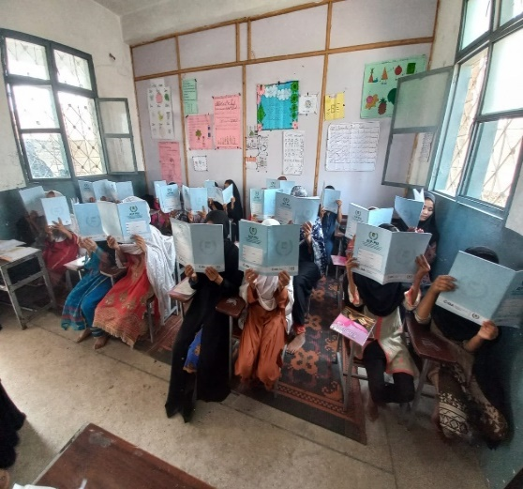Facilitators received contracts for the period of nine months, from April to December 2023 and they also received a stipend of Rs 50000 each for the first two months (April-May 2023).

Figure : Inside view of ALP center and notebooks supplied by ALP-PIU

* All the registers, including Learner’s Attendance, Staff Attendance, VNF, Stock, Learners Admission and Withdrawal, and Visitors Register were diligently maintained and updated.
* A Volunteer Network Forum (VNF) consisting of 08 members was established including 07 female and 01 male member, and the minutes of the VNF meeting were recorded and updated in the VNF register, along with the members details.

1. **ALP Center Swati Phatak Umeed Abad No.02 (Female)**

|  |  |  |  |  |  |
| --- | --- | --- | --- | --- | --- |
| Total Learners Registered | Local Learners | Afghan Refugees | Withdrawal | Present at the time of visit | No. Of Facilitators |
| 30 | 22 | 08 | 00 | 25 | 02 |

**Key Findings:**

* The center is in a private school and has been operational since April 1st, 2023.
* The center is functioning during the evening shift from 02:00 pm to 07:00 pm.
* The ALP-PIU supplied various items to this center, including a signboard, school bags, notebooks, Package-D, dictionaries, water cooler, two steel glasses, and charts. However, facilitator and learner chairs were not supplied till visit day.
* The Learners were seated in one room with sufficient lighting. Furniture was available for both the learners as well as facilitators.
* The age range of the learners was between 12 and 18 years.
* The center had a proper washroom facility for the learners and drinking water was also available.
* A group of women in a classroom

  Description automatically generated with medium confidenceBoth facilitators (Ms. Sanam and Ms. Gulnaz) were residents of the area and were present at the center. Ms. Gulnaz holds a BA degree and is physically challenged. Despite her physical condition, she comes to the center regularly and is very motivated to serve the community by teaching children. She expressed heartfelt gratitude to ALP-PIU and all others who supported the establishment of the center.

Figure : Inside view of ALP center

* Facilitators received contract agreements for a period of nine months, from April to December 2023 and they also received stipends for the first two months (April-May 2023).
* All the registers were properly maintained except Volunteer Network Forum (VNF) register.
* Volunteer Network Forum (VNF) was formed, comprising of 08 male members. The roles and responsibilities of the VNF were not displayed, although they were properly recorded and updated in the VNF registers, which also contained detailed information about the members.

**Conclusion**

* All the centers visited were successfully established in the month of April 2023 and were operational.
* The centers were provided with necessary supplies including sign boards, white boards, school bags, notebooks, Package-D and water coolers and two glasses each by the PIU. However, facilitators and learners’ chairs were not supplied till visit day.
* A set of six registers, including Learners Attendance, Staff Attendance, VNF, Stock, Learners Admission and Withdrawals and Visitors Register was provided to each center which were properly maintained.
* During the visit, it was observed that each center had an enrollment range of 30 to 35 learners with two allocated facilitators present at each center.
* In each center, the Village Network Forum (VNF) was found functional. The roles and responsibilities of the VNF, as well as meeting minutes, were recorded in the VNF registers.
* All the facilitators received stipends (Rs 50,000 each) for the duration of two months.
* During the visit, it was observed that in Landi Arbab, the centers within GGPS Charkha Khel were not allowed to have signboards by the principal, despite other organizations (Relief International etc.) having their signboards displayed.
* In UC Landi Arbab, the centers named Mohalla Gulab Khan and Garhi Loharan were shifted to the community houses as the school principals declined to accommodate the ALP centers within respective institutions. Moreover, the displayed address on the signboard was different from the actual location.
* Several schools were found shifted from evening to the morning shift but the same information wasn’t updated in the PIU record.